Techniques

React Native

DynamoDB/Google calendars

Functionality

* Calendar.
  + Easy add/remove data
  + Set amount of presets
  + Keep track of averages (month/week/year)
* Link to stretch exercices

Colors

#303266 background-light

#2b2d5c background

#f84358 red

#219653 green

#fcce3c yellow

#45cdff teal (light blue)

#5260eb blue (purple)

#ffffff white

#474984 grey

#D3D5FD light grey

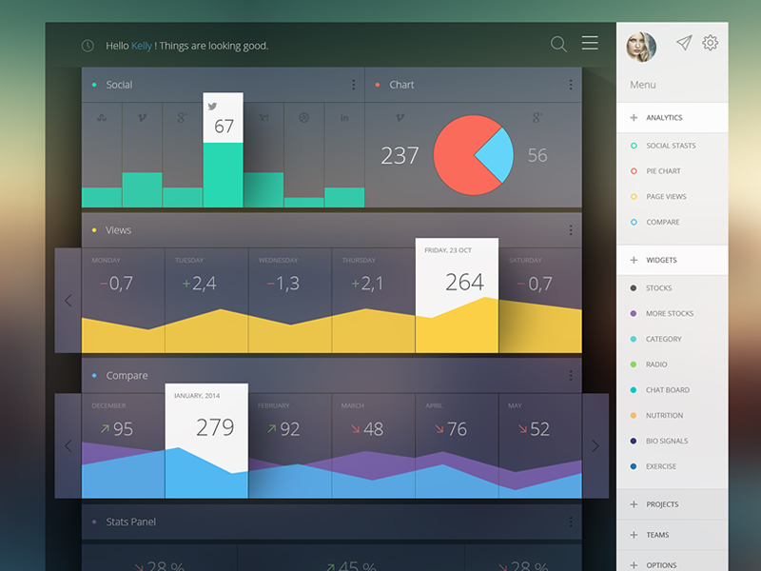

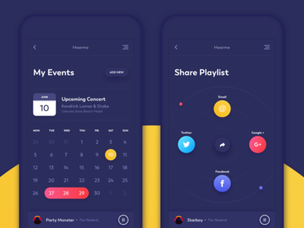Add event

* Click plus (bottom right)
* Bounce animation 4 icons (back in middle)
  + Icons for stretch, run, … (color coded)
* Optional more icons
  + Eg. Stretch 4 more icons (per muscle group)
* Simple add dot (color coded)

Designs/inspiration

|  |  |
| --- | --- |
| https://github.com/Ramotion/fluid-slider/raw/master/fluid-slider.gif | Iphone sidebar perspective |
| Calendar and Share screens (dark theme) | <https://dribbble.com/shots/701486-clyp-iPhone-Sidebar> |
| https://cdn.dribbble.com/users/108163/screenshots/2471798/16-01-2015__1x.jpg | Calendar UI |
|  |  |